**SQL EXERCISES**

1. Write a SQL statement to display all the information of all salesmen.

**SELECT \***

**FROM salesman**

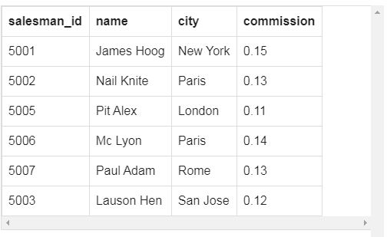

1. Write a SQL statement to display specific columns like name and commission for all the salesmen.

**SELECT name,commission**

**FROM salesman**

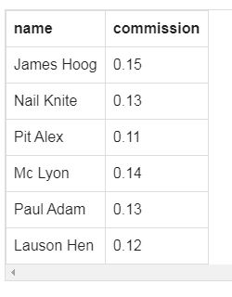

1. Write a query to display the columns in a specific order like order date, salesman id, order number and purchase amount from for all the orders.

**SELECT ord_date,salesman_id,ord_no, purch_amt**

**FROM orders**

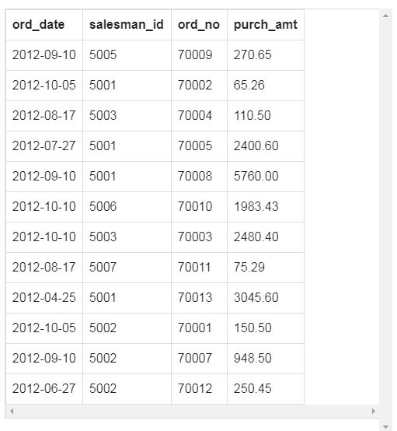

1. Write a query which will retrieve the value of salesman id of all salesmen, getting orders from the customers in orders table without any repeats.

**SELECT DISTINCT salesman_id**

**FROM orders**

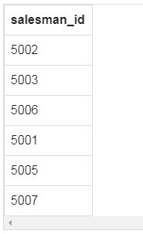

10. Write a SQL statement to display all the information for those customers with a grade of 200.

**SELECT \***

**FROM customer**

**WHERE grade =200**

1. 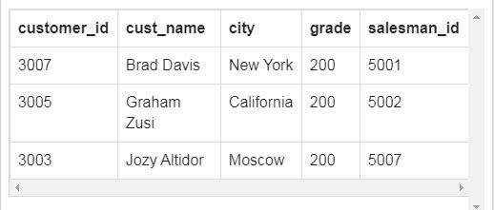 Write a SQL query to display the Nobel prizes for 1970.

**SELECT \***

**FROM nobel_win**

**WHERE year =1970**

